Assignment 1 Computational Potential Flow Analysis

Academic year: 2025-2026

|  |  |
| --- | --- |
| Name | Dennis Heintz |
| Student ID | 6219675 |
| Email address | dheintz@tudeft.nl |

|  |
| --- |
| Date : 22.01.2025 |

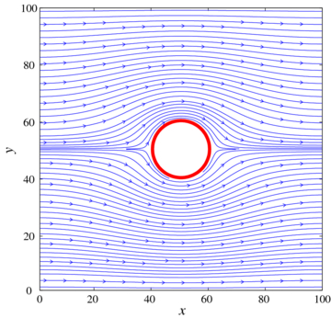 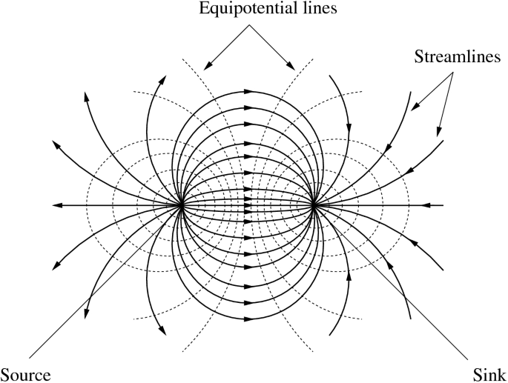

**Contents**

1 Introduction 3

1.1 Foundational Flow Solutions 3

1.2 Solver Development 3

1.3 Inviscid Flow Analysis over a Body 3

2 Foundations 3

2.1 Canonical flows 3

2.2 Lift generation 5

3 Solver development 7

4 Analysis of the flow over a 2D body 10

4.1 Option A – Wing and tail downwash 10

4.2 Option B – Wing in ground effect 11

4.3 Option C – Rotating cylinder aircraft 12

4.4 Option D – Windtunnel blockage correction 14

# Introduction

This assignment is designed to bridge the theoretical foundations of potential flow with practical computational analysis, enabling the prediction of inviscid flow fields. The overall goal is to build a basic computational framework for fluid analysis using the principle of superposition and apply it to a specific body shape.

* The assignment should be handled **individually**. We suggest you fill in **this template** to produce the assignment.
* Please note that you are requested to **put all 5 Assignments** in this course into **one final report** that is to be delivered in **PDF-format** at the end of the lecture series (see additional information on BrightSpace.
* Separate assignment reports will not be graded.

This assignment is structured into three phases.

## Foundational Flow Solutions

First you will review the four canonical, fundamental flow solutions that serve as the building blocks for all complex potential flow scenarios:

* the **uniform flow**
* the **source/sink**
* the **doublet**
* the **irrotational vortex**.

Your discussion must detail the physical nature, mathematical properties, and appropriate coordinate system representations (Cartesian or Polar) for each solution, including the equations for the stream function ($ψ$) and the potential function ($ϕ$).

## Solver Development

Building upon the theoretical definitions, you will develop one or more short, efficient scripts or "solvers". These computational tools must be capable of combining the canonical solutions (via the principle of superposition) to calculate the resultant velocity components, stream function values, and potential function values at arbitrary points in a flow field. This phase will establish the necessary computational tool for analyzing some complex flow scenarios.

## Inviscid Flow Analysis over a Body

Finally, the developed solver(s) will be applied to analyze the inviscid flow over a specific body (for example a Rankine body or a cylinder with circulation). You will use your script to map the complete flow field, locate stagnation points, and compute the pressure distribution or forces (if applicable) for the specified configuration. This phase requires demonstrating the ability to connect the theoretical superposition of flows to a real-world (inviscid) aerodynamic problem.

# Foundations

## Canonical flows

For each one of the four canonical flow solutions as discussed in section 1.1, write down the corresponding equation for the stream function and potential function and create a hand drawing picture of the flow streamlines created by it.

This handwritten part should be put in the frame underneath.

*Note:*

*For all subsequent frames in this assignment: only if needed the size of this frame may be extended a little bit. However, we advise to stick to the size provided to ensure conciseness of your answers.*

**For all handwritten parts in this report: add your signature and date!**

|  |
| --- |
| Handwritten potential flow solutions and pictures of the associated streamlines |
|  |

## Lift generation

Potential flow theory assumes irrotational flow, nevertheless, it can be used to demonstrate lift generation. This required a special treatment of the equations applied.

* Handwrite the definitions of vorticity and circulation in the frame underneath.

|  |
| --- |
| Handwritten definitions of vorticity and circulation |
|  |

* Add a handwritten text with the equation that relates circulation and lift generation (Kutta-Joukowski Theorem) and explain how the flow over a lifting cylinder (2D flow) can be modeled.

|  |
| --- |
| Handwritten text on modeling of lifting cylinder, add a drawing if you like. |
|  |

* In potential flow theory, explain how circulation can exist without the presence of distributed vorticity. Also indicate why, in practice, lift cannot be produced without the presence of viscosity (=potential flow).

|  |
| --- |
| Description of non-zero circulation in potential flow. |
| In potential flow theory, circulation can exist without the presence of distributed vorticity as circulation is introduced through the use of singularities. An irrotational vortex is considered a singularity as the flow velocity approaches infinity at its center. This confines the vorticity to a singular point instead of being distributed through the flow field. The circulation around a closed contour can then be found to be non-zero if it encircles such a singularity, otherwise the circulation will be zero.  In practice, these singularities are unphysical. Instead, vorticity is introduced by the velocity gradients that form in boundary layers of bodies due to the presence of viscosity. The vorticity at the surface of such bodies creates net circulation around them and, as per the Kutta-Joukowski theorem, this circulation produces lift. |

* In potential flows over lifting airfoil we need the concept of the so-called Kutta condition. In the frame below explain (handwritten or typed) what this condition entails and why this is needed for predicting realistic flow over an airfoil. Moreover, add a handmade sketch of the flow over an airfoil for which the Kutta condition is neglected.

|  |
| --- |
| Discussion on the Kutta condition. |
| The Kutta condition dictates that the flow must leave the trailing edge smoothly. This results in the rear stagnation point being located at the trailing edge and that the velocity of the flow at the trailing edge to be finite and non-zero. If the Kutta condition was not enforced the flow would look like in the figure below. |

# Solver development

Create a code that allows you to add a series of canonical flows (all types) at user selected locations. The user should be able to input the types of sources and location of those sources in **2D**. The output of this code are four fields

1. the stream function field
2. the potential function field
3. the velocity field (x, and y component)
4. the pressure coefficient field

* In the frame below, add a hand sketched flow diagram of your code along with the equations applied in the various steps.

|  |
| --- |
| Discussion. |
| Equations for the stream function, potential function and velocity components are shown in Part 2.1.  The absolute velocity was calculated by: $$v=\sqrt{u^{2}+v^{2}}$$ The pressure coefficient was calculated by: $$C_{P}=1-\frac{v}{v_{∞}}$$ As certain potential flow functions are easier show in polar coordinates, such as for the source, sink, and vortex, the cartesian coordinates of the flow were transformed into polar coordinates by: $$θ=arctan2\left(\frac{y}{x}\right)$$ $$r=\sqrt{x^{2}+y^{2}}$$ |

Now, validate this code by testing the flow field over a **rotating cylinder**.

* + Plot the resulting pressure over the cylinder surface or alternatively the streamlines over the model, for three different angular velocities: zero, small and large (by selecting the vortex strength).

|  |
| --- |
| Plots of surface pressure distribution or streamlines for three cylinder rotational speeds |
|  |

* + Compare the above with the theoretical model and explain discrepancies if present.

|  |
| --- |
| Comparison with theoretical rotating cylinder flow |
| The plots produced above match the theoretical plots found online very well. The three chosen cases were matched to the three cases shown in the plot below. No discrepancies are immediately noticeable.  <https://eaglepubs.erau.edu/introductiontoaerospaceflightvehicles/chapter/potential-flows/> |

* + Compute the $C_{l}$, lift coefficient, of the cylinder for different angular velocities (non-dimensionalized by flow speed and cylinder diameter). What is your key observation here?

|  |
| --- |
| Discussion on the lift coefficient of the rotating cylinder |
| |  |  | | --- | --- | | Angular Velocity [rad/s] | Lift Coefficient [-] | | 0 | 0 | | 0.159 | 6.283 | | 0.318 | 12.566 |   The lift coefficient of the rotating cylinder increases linearly with the angular velocity. This is expected as the angular velocity, $u_{r}$, is proportional to the vortex strength, which is also the case for the lift coefficient. In reality, flow separation would occur before reaching such high lift coefficients, which limits the applicability of potential flow theory for high angular velocities. |

# Analysis of the flow over a 2D body

In this part of the assignment, you **should select one of the options** provided below to model the flow over a 2D body. You may model the flow field using the code you created in above or select an existing (e.g. open source) low fidelity potential flow code if you feel this is needed. In the latter case provided full reference to that code and shortly discuss its validity and applicability for the given problem.

Although the cases sketched underneath typically produce a 3D flow, in this assignment we limit ourselves to **2D flow**. Obviously, this is a serious simplification of the real flow around the body.

## Option B – Wing in ground effect

Ground effect can have an extreme impact on an aircraft lift while close to the ground. Accounting for this effect is fundamental, for example, for Ekranoplanes. To model this effect, in 2D, we ask:

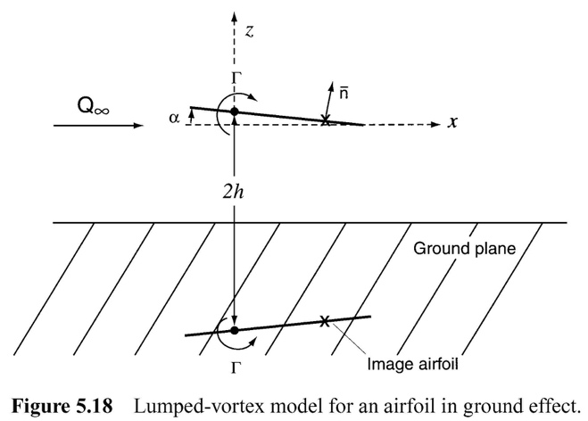

* + Model the flow over the 2D wing in ground effect using your own or another preferred code and perform the following task.
  + Simulate a 2D wing in ground effect for different values of distance to the ground, $h$.
  + Provide a plot of the lift coefficient, C_L versus h and shortly discuss the results. What are the potential pros and cons of a lift in ground effect vehicle compared to an aircraft?

|  |
| --- |
| Discussion on the wing in ground effect results |
| As can be seen in the figure above, the lift coefficient increases exponentially as the height of the airfoil decreases. This, however, is only true within one chord length of the ground as the lift coefficient rapidly approaches the freestream value as the airfoil moves away from the ground.  A benefit of the ground effect is that the wing is more efficient at generating lift. This allows ground effect vehicles to fly more efficiently and burn less fuel to stay in the air. Furthermore, the induced drag of the wing is decreased which leads to an improved L/D ratio of the wing. As a result, a smaller, and therefore, lighter wing can be used on a ground effect vehicle.  Downsides of ground effect vehicles include a very limited altitude range they can operate in, less maneuverability as the vehicle is very close to the ground, and ground effect vehicles require a very flat and smooth terrain to operate properly. Finally, an airfoil in ground effect is more prone to stall as the flow around the leading edge is more prone to separating at lower angles of attack. |

=== END OF ASSIGNMENT # 1 ===